A Project Report on

CLEANING AND ORGANIZING STUDENT

ATTENDANCE RECORDS IN R

Submitted in partial fulfillment of requirements for the award of the course of

AGI1252 – R PROGRAMMING

Under the guidance of

Mrs. SRI SANTHOSHINI M.E.,

Assistant Professor / AI

Submitted By

MONIKA SRIE K (2303811714822021)

DEPARTMENT OF ARTIFICIAL INTELLIGENCE AND MACHINE LEARNING

K.RAMAKRISHNAN COLLEGE OF TECHNOLOGY
(Autonomous)

TRICHY – 621 112
JUNE 2025

i

K.RAMAKRISHNAN COLLEGE OF TECHNOLOGY
(Autonomous Institution affiliated to Anna University, Chennai)

TRICHY– 621 112 BONAFIDE CERTIFICATE
Certified that this project report on “ HOTEL RESERVATION SYSTEM” is the bonafide work of VETHAABINAYA. S(2303811714822054) who carried out the project work during the academic year 2024 - 2025 under my supervision.


Signature

Signature
Mrs. SRI SANTHOSHINI M.E., Dr. T. AVUDAIAPPAN M.E.,Ph.D.,

SUPERVISOR, HEAD OF THE DEPARTMENT,

Department of Artificial Intelligence, Department of Artificial Intelligence
K. Ramakrishnan College of Technology , K. Ramakrishnan College of Technology , Samayapuram, Trichy -621 112. Samayapuram, Trichy -621 112.
Submitted for the viva-voce examination held on 03-12-2024




INTERNAL EXAMINER EXTERNAL EXAMINER

DEPARTMENT OF ARTIFICIAL INTELLIGENCE
VISION OF THE INSTITUTION
To serve the society by offering top-notch technical education on par with global standards.

MISSION OF THE INSTITUTION
- Be a centre of excellence for technical education in emerging technologies by exceeding the needs of industry and society.
- Be an institute with world class research facilities.
- Be an institute nurturing talent and enhancing competency of students to transform them as all- round personalities respecting moral and ethical values.
VISION AND MISSION OF THE DEPARTMENT

To excel in education, innovation and research in Artificial Intelligence and Machine Learning to fulfill industrial demands and societal expectations.
Mission 1: To educate future engineers with solid fundamentals, continually improving teaching methods using modern tools.
Mission 2: To collaborate with industry and offer top-notch facilities in a conductive learning environment.
Mission 3: To foster skilled engineers and ethical innovation in AI and ML for global recognition and impactful research.
Mission 4: To tackle the societal challenge of producing capable professionals by instilling employability skills and human values.
PROGRAM EDUCATIONAL OBJECTIVES (PEOS)

PEO 1: Compete on a global scale for a professional career in Artificial Intelligence and Machine Learning.
PEO 2: Provide industry-specific solutions for the society with effective communication and ethics.
PEO 3: Hone their professional skills through research and lifelong learning initiatives.

PROGRAM OUTCOMES :
Engineering students will be able to:
- Engineering knowledge: Apply the knowledge of mathematics, science, engineering fundamentals, and an engineering specialization to the solution of complex engineering problems.
- Problem analysis: Identify, formulate, review research literature, and analyze complex engineering problems reaching substantiated conclusions using first principles of mathematics, natural sciences, and engineering sciences.
- Design/development of solutions: Design solutions for complex engineering problems and design system components or processes that meet the specified needs with appropriate consideration for the public health and safety, and the cultural, societal, and environmental considerations.
- Conduct investigations of complex problems: Use research-based knowledge and research methods including design of experiments, analysis and interpretation of data, and synthesis of the information to provide valid conclusions.
- Modern tool usage: Create, select, and apply appropriate techniques, resources, and modern engineering and IT tools including prediction and modeling to complex engineering activities with an understanding of the limitations.
- The engineer and society: Apply reasoning informed by the contextual knowledge to assess societal, health, safety, legal and cultural issues and the consequent responsibilities relevant to the professional engineering practice.
- Environment and sustainability: Understand the impact of the professional engineering solutions in societal and environmental contexts, and demonstrate the knowledge of, and need for sustainable development.
- Ethics: Apply ethical principles and commit to professional ethics and responsibilities and norms of the engineering practice.
- Individual and team work: Function effectively as an individual, and as a member or leader in diverse teams, and in multidisciplinary settings.

- Communication: Communicate effectively on complex engineering activities with the engineering community and with society at large, such as, being able to comprehend and write effective reports and design documentation, make effective presentations, and give and receive clear instructions.
- Project management and finance: Demonstrate knowledge and understanding of the engineering and management principles and apply these to one’s own work, as a member and leader in a team, to manage projects and in multidisciplinary environments.
- Life-long learning: Recognize the need for, and have the preparation and ability to engage in independent and life-long learning in the broadest context of technological change.

PROGRAM SPECIFIC OUTCOMES (PSOs)
  - PSO 1: Capable of working on data-related methodologies and providing industry-focussed solutions.
  - PSO2: Capable of analysing and providing a solution to a given real-world problem by designing an effective program.

ABSTRACT

Accurate and well-organized attendance records are crucial for monitoring student engagement, academic performance, and institutional compliance. However, raw attendance data often suffer from inconsistencies, missing values, and formatting issues, making analysis and reporting challenging. This project focuses on the cleaning and organization of student attendance records using the R programming language. Leveraging R's powerful data manipulation packages such as dplyr, tidyr, and lubridate, the project demonstrates systematic techniques for handling incomplete entries, correcting date formats, resolving duplication, and standardizing student identifiers. The cleaned and structured data is then prepared for further analysis and visualization. This approach not only improves data quality but also facilitates the generation of meaningful insights for educators and administrators. The project highlights the importance of data preprocessing and showcases R as an efficient tool for educational data management.

TABLE OF CONTENTS

CHAPTE R  No. | TITLE | PAGE  No.
 | ABSTRACT | vi
1 | INTRODUCTION | 1
 | 1.1 Objective | 1
 | 1.2 Overview | 1
 | 1.3 Java Programming concepts | 2
2 | PROJECT METHODOLOGY | 3
 | 2.1Proposed Work | 3
 | 2.2 Block Diagram | 3
3 | MODULE DESCRIPTION | 4
 | 3.1 User input Module | 4
 | 3.2 Room Module | 4
 | 3.3 Reservation Module | 4
4 | RESULTS AND DISCUSSION | 5
5 | CONCLUSION | 7
 | REFERENCES | 8
 | APPENDIX | 9

CHAPTER 1 INTRODUCTION

  - Objective:
The The objective of this project is to develop an efficient and systematic approach to clean, organize, and standardize student attendance records using the R programming language. This includes identifying and correcting inconsistencies, handling missing or duplicate entries, standardizing date formats, and preparing the data for accurate analysis and reporting. The goal is to ensure high data quality that supports meaningful insights into student attendance patterns and improves decision-making for academic institutions
Additionally, this project aims to create reproducible workflows that can be applied to future attendance datasets. It seeks to reduce manual effort and minimize errors through automation and scripting in R. Ultimately, the project will contribute to more reliable student data management and improved administrative efficiency.
Overview
Th Managing student attendance data is a critical task for educational institutions, yet the raw data collected from various sources is often messy, inconsistent, and difficult to interpret. This project addresses these challenges by leveraging the R programming language to clean, organize, and structure attendance records for accurate and efficient use. The process involves detecting and handling missing values, correcting data entry errors, standardizing formats (such as dates and student IDs), and removing duplicate records. Using R packages such as dplyr, tidyr, and lubridate, the project demonstrates how to transform disorganized datasets into clean, analyzable formats.
The organized dataset can then be used for reporting, visualization, and identifying trends in student attendance, supporting both academic planning and administrative decision-making. This project serves as a practical example of how data science tools can be applied to solve real-world problems in the education sector

  - R Programming Concepts
1. Data Types and Structures
Understanding and using R's basic data structures like vectors, factors, lists, data frames, and tibbles is essential. Attendance data is usually stored in data frames, and recognizing each column's type (e.g., date, character, logical) is key for proper handling.
2. Indexing and Subsetting
This involves selecting specific rows or columns from a dataset. For example, subsetting attendance records for a specific student or date range is a common task
3. Conditional Logic
This allows decision-making in code. Using constructs like if, else, ifelse(), or case_when() helps in classifying attendance (e.g., turning missing values into “Absent” or identifying anomalies).

4. Iteration and Looping
Using for, while, or the apply family of functions lets you perform repeated tasks. While R is more efficient with vectorized operations, loops may still be used for custom logic across records.

5. Vectorization
This is a way to apply operations across entire columns without writing explicit loops. For instance, updating an entire “Status” column using ifelse() is a vectorized approach.

6. Functions
Encapsulating repetitive logic into reusable blocks makes code modular and easier to maintain. You might write a function like clean_attendance_data() that performs all cleaning steps

  - Proposed Work

CHAPTER 2 PROJECT METHODOLOGY

The proposed work aims to develop an efficient R-based system for cleaning and organizing student attendance records. This involves acquiring raw data from CSV or Excel files and performing an initial inspection to identify issues such as missing values, duplicates, and inconsistent formats. The data will then be cleaned by standardizing column names, converting date formats, and normalizing attendance status values. Using data transformation techniques, the records will be reshaped into a tidy format where each row represents one attendance entry per student per date. Aggregation functions will be applied to compute total days present, absent, and attendance percentages for each student. Modular programming practices will be used to create reusable functions for data cleaning, transformation, and summarization. The cleaned and summarized datasets will be exported in structured formats for further analysis or reporting. Optional enhancements include visual summaries using ggplot2 or interactive interfaces using shiny. The final outcome will be a reusable and scalable framework for managing attendance data efficiently.
  - Block Diagram

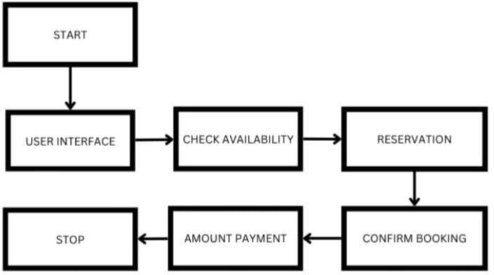

CHAPTER 3 MODULE DESCRIPTION
  - Module 1 :User Input Module
This module is responsible for collecting user-defined inputs such as:
- File paths for raw attendance data
- Date ranges to analyze
- Filters like specific classes or students
It can be a manual prompt in a script, or parameters passed to functions.

Module 2: Data Loading Module
Handles importing attendance data from external sources like:
- .csv, .xlsx, or .rds files
This module validates the file format and checks for essential columns such as Student ID, Name, Date, and Attendance Status.

Module 3: Data Cleaning Module
Processes and prepares raw data by:
- Removing duplicates and blank rows
- Handling missing values (e.g., replacing NA with "Absent")
- Standardizing column names and attendance statuses
- Converting dates into proper format

Module 4: Attendance Processing Module
This is the heart of the system. It:
- Structures data into tidy format
- Ensures each row represents a student’s attendance on a specific date
- Normalizes entries like "P", "Present", etc.

Module 5: Calculation Module
Performs all attendance-related computations:
- Total number of classes
- Number of days present and absent
- Attendance percentage
- Flags low attendance cases (optional)

Module 6: Summary and Reporting Module
Generates:
- Student-wise summaries
- Class or date-level attendance overviews
- Optional charts or summaries for reports
It may also prepare data for visualization or export.

Module 7: Output Module
Handles exporting processed data to external files:
- Cleaned dataset (CSV or RDS)
- Summary tables
- Attendance matrix (optional)

Module 8: (Optional) Visualization Module
Creates graphs or dashboards using libraries like ggplot2 or shiny, such as:
- Bar charts of attendance percentages
- Time-series of daily attendance trends

Module 9: Logging and Error Handling Module
Keeps track of errors or invalid inputs, such as:
- Missing columns
- Incorrect formats
- Date mismatches
Helps make the system more robust and user-friendly.

Module 10: Configuration Module
If building a reusable system, this module holds configurable values:
- Threshold for low attendance
- Date formats
- Accepted status labels

User Input:

  - Room Type:

CHAPTER 4 RESULTS AND DISCUSSION

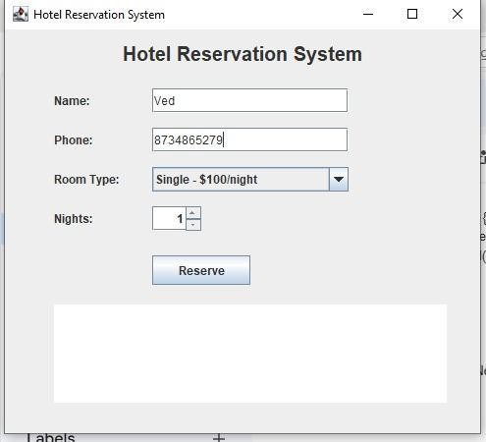

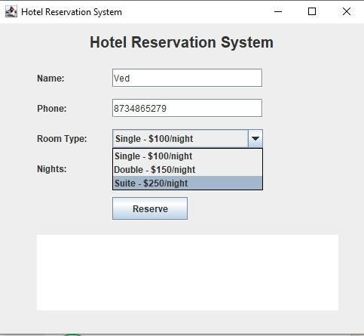

  - Reservation :

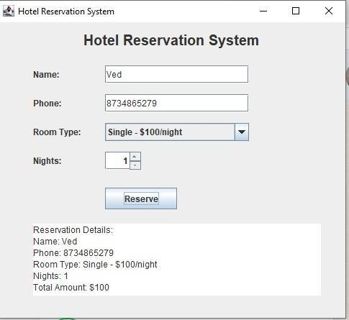

CHAPTER 5 CONCLUSION

In summary, the development of a systematic R-based approach for cleaning and organizing student attendance records enhances data reliability and usability for educational analysis. By applying key programming concepts such as data cleaning, transformation, aggregation, and modular design, the process ensures that raw and often inconsistent attendance data is converted into a clean, standardized, and analyzable format. This structured framework not only streamlines attendance management but also facilitates accurate reporting and decision-making for educators and administrators. Implementing such a solution promotes efficiency, reduces manual errors, and supports scalable data handling across academic periods.

REFERENCES:
Wickham, H., & Grolemund, G. (2017). R for Data Science: Import, Tidy, Transform, Visualize, and Model Data. O’Reilly Media.
Wickham, H. (2023). dplyr: A Grammar of Data Manipulation. R package version 1.1.0. https://CRAN.R-project.org/package=dplyr
Grolemund, G., & Wickham, H. (2011). Dates and Times Made Easy with lubridate. Journal of Statistical Software, 40(3), 1-25. https://www.jstatsoft.org/article/view/v040i03
R Core Team. (2024). R: A Language and Environment for Statistical Computing. R Foundation for Statistical Computing, Vienna, Austria. https://www.R-project.org/

APPENDIX
(Coding)

# app.R - Advanced Attendance Dashboard

library(shiny)
library(tidyverse)
library(lubridate)
library(plotly)
library(tidyr)

# UI
ui <- fluidPage(
titlePanel("Student Attendance Dashboard"),

sidebarLayout(
sidebarPanel(
fileInput("file", "Upload Attendance CSV File", accept = ".csv"),
helpText("Default: student_attendance.csv in working directory."),
actionButton("analyze", "Run Cleaning & Analysis")
),

mainPanel(
tabsetPanel(
tabPanel("Summary Table", tableOutput("summary")),
tabPanel("Pie Chart", plotlyOutput("piechart")),
tabPanel("Attendance % by Student", plotlyOutput("barplot"))
)
)
)
)

# SERVER
server <- function(input, output) {

# Load file or use default
data_input <- reactive({
infile <- input$file
if (is.null(infile)) {
read_csv("student_attendance.csv", show_col_types = FALSE)
} else {
read_csv(infile$datapath, show_col_types = FALSE)
}
})

# Clean and process data
cleaned_data <- eventReactive(input$analyze, {
df <- data_input()
colnames(df) <- c("StudentID", "Name", "Date", "Status")

df <- df %>%
mutate(
Date = parse_date_time(Date, orders = c("ymd", "mdy", "dmy", "Y/m/d")),
Status = tolower(trimws(Status)),
Status = case_when(
Status %in% c("present", "presnt", "p") ~ "Present",
Status %in% c("absent", "a") ~ "Absent",
Status == "" | is.na(Status) ~ "Unknown",
TRUE ~ str_to_title(Status)
)
) %>%
group_by(Name) %>%
fill(StudentID, .direction = "downup") %>%
ungroup() %>%
filter(!is.na(StudentID), !is.na(Date), !is.na(Name)) %>%
distinct() %>%
arrange(StudentID, Date)

df
})

# Summary stats
summary_stats <- reactive({
cleaned_data() %>%
group_by(StudentID, Name) %>%
summarise(
TotalDays = n(),
Present = sum(Status == "Present"),
Absent = sum(Status == "Absent"),
Unknown = sum(Status == "Unknown"),
AttendancePercent = round((Present / TotalDays) * 100, 2),
.groups = "drop"
) %>%
arrange(desc(AttendancePercent))
})

output$summary <- renderTable({
summary_stats()
}, striped = TRUE, hover = TRUE, bordered = TRUE)

output$piechart <- renderPlotly({
status_counts <- cleaned_data() %>%
count(Status)

plot_ly(status_counts, labels = ~Status, values = ~n, type = "pie") %>%
layout(title = "Attendance Status Distribution")
})

output$barplot <- renderPlotly({
summary_stats() %>%
plot_ly(x = ~reorder(Name, AttendancePercent), y = ~AttendancePercent,
type = 'bar', name = 'Attendance %',
text = ~paste(AttendancePercent, "%"), textposition = 'auto',
marker = list(color = 'lightblue')) %>%
layout(title = "Attendance Percentage by Student",
xaxis = list(title = "Student Name", tickangle = -45),
yaxis = list(title = "Attendance %"),
margin = list(b = 120))
})
}

# Run the app
shinyApp(ui = ui, server = server)

